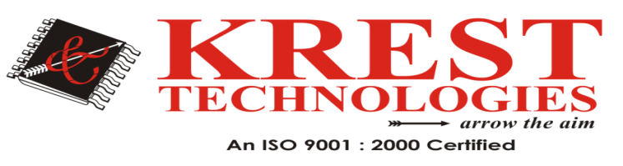

M.Tech CSE Major Projects List (2021-20)

 | Secure Computing
1 | Secure Fast Covariance Intersection Using Partially Homomorphic and Order Revealing Encryption Schemes | 2021
2 | Coded Computing for Resilient, Secure, and Privacy-Preserving Distributed Matrix Multiplication | 2020
3 | Enforcing Access Control in Information-Centric Edge Networking | 2020
4 | A Verifiable Semantic Searching Scheme by Optimal Matching over Encrypted Data in Public Cloud | 2020
5 | Rethinking Secure Precoding via Interference Exploitation: A Smart Eavesdropper Perspective | 2020
6 | MARP: A Distributed MAC Layer Attack Resistant Pseudonym Scheme for VANET | 2018
7 | FastGeo: Efficient Geometric Range Queries on Encrypted Spatial Data | 2017
8 | Privacy-Preserving Multi-keyword Top-k Similarity Search Over Encrypted Data | 2017

HeadOffice: #202 2nd Floor, Pancom Business Center Opp, Chennai Shopping Mall, Ameerpet, Hyderabad 040-44433434 Mail-id: ramu.krest@gmail.com,www.kresttechnology.com

